Looping Logic
# Source: AI Source: Provided by: [Data Path: Persons Table -> ID Column: 1, Name_En Column: Motasem Essam] -> From: [Chatgpt (GPT‑5 Mini)] on [12/9/2025]
Looping Logic is used to repeat a block of code multiple times until a condition is met.
👉 It answers the question:
“Do this again and again until something changes.”

🔑 Key Idea
# Source: AI Source: Provided by: [Data Path: Persons Table -> ID Column: 1, Name_En Column: Motasem Essam] -> From: [Chatgpt (GPT‑5 Mini)] on [12/9/2025]
Execute code multiple times automatically instead of writing it repeatedly

🧩 Basic Example
# Source: AI Source: Provided by: [Data Path: Persons Table -> ID Column: 1, Name_En Column: Motasem Essam] -> From: [Chatgpt (GPT‑5 Mini)] on [12/9/2025]
for (int i = 0; i < 5; i++) {
System.out.println(i);
}
👉 Output:
0 1 2 3 4

🧱 Common Types of Loops

1️⃣ for Loop (Known number of iterations)
# Source: AI Source: Provided by: [Data Path: Persons Table -> ID Column: 1, Name_En Column: Motasem Essam] -> From: [Chatgpt (GPT‑5 Mini)] on [12/9/2025]
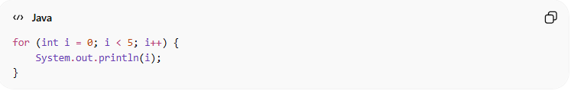
for (int i = 0; i < 3; i++) {
System.out.println("Hello");
}
👉 Use when you know how many times to repeat

2️⃣ while Loop (Condition-based)
# Source: AI Source: Provided by: [Data Path: Persons Table -> ID Column: 1, Name_En Column: Motasem Essam] -> From: [Chatgpt (GPT‑5 Mini)] on [12/9/2025]
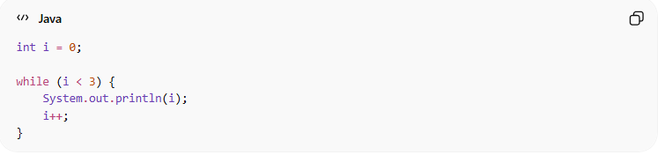
int i = 0;

while (i < 3) {
System.out.println(i);
i++;
}
👉 Runs while condition is true

3️⃣ do-while Loop (Runs at least once)
# Source: AI Source: Provided by: [Data Path: Persons Table -> ID Column: 1, Name_En Column: Motasem Essam] -> From: [Chatgpt (GPT‑5 Mini)] on [12/9/2025]
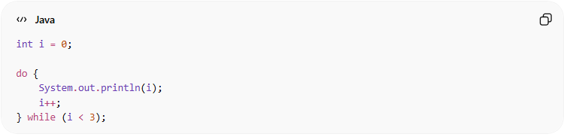
int i = 0;

do {
System.out.println(i);
i++;
} while (i < 3);
👉 Executes at least once, even if condition is false

4️⃣ for-each Loop (Collections)
# Source: AI Source: Provided by: [Data Path: Persons Table -> ID Column: 1, Name_En Column: Motasem Essam] -> From: [Chatgpt (GPT‑5 Mini)] on [12/9/2025]
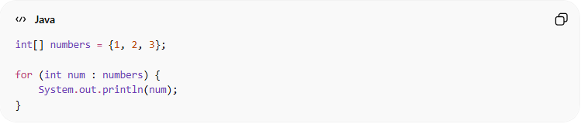
int[] numbers = {1, 2, 3};

for (int num : numbers) {
System.out.println(num);
}
👉 Used for arrays and collections

❌ Bad Example (Infinite Loop)
# Source: AI Source: Provided by: [Data Path: Persons Table -> ID Column: 1, Name_En Column: Motasem Essam] -> From: [Chatgpt (GPT‑5 Mini)] on [12/9/2025]
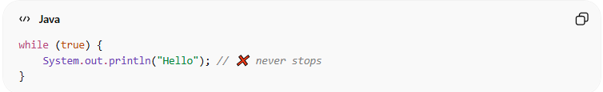
while (true) {
System.out.println("Hello"); // ❌ never stops
}
👉 Problem:
- No exit condition → program may crash

❌ Bad Example (Hard to Read)
# Source: AI Source: Provided by: [Data Path: Persons Table -> ID Column: 1, Name_En Column: Motasem Essam] -> From: [Chatgpt (GPT‑5 Mini)] on [12/9/2025]
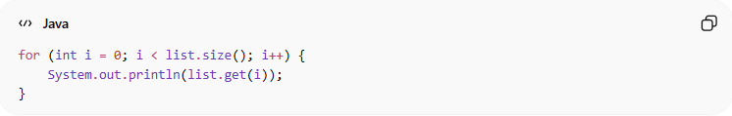
for (int i = 0; i < list.size(); i++) {
System.out.println(list.get(i));
}
👉 Less readable for collections

✅ Good Example (Clean Loop)
# Source: AI Source: Provided by: [Data Path: Persons Table -> ID Column: 1, Name_En Column: Motasem Essam] -> From: [Chatgpt (GPT‑5 Mini)] on [12/9/2025]
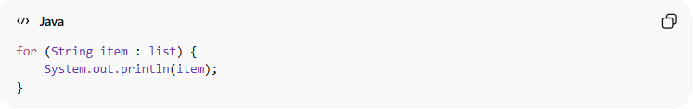
for (String item : list) {
System.out.println(item);
}
👉 Cleaner and easier to understand

💡 Best Practices
# Source: AI Source: Provided by: [Data Path: Persons Table -> ID Column: 1, Name_En Column: Motasem Essam] -> From: [Chatgpt (GPT‑5 Mini)] on [12/9/2025]
- Always define a clear exit condition
- Avoid infinite loops unless intentional
- Use the right loop type for the situation
- Keep loop body simple and small

🧾 Summary
# Source: AI Source: Provided by: [Data Path: Persons Table -> ID Column: 1, Name_En Column: Motasem Essam] -> From: [Chatgpt (GPT‑5 Mini)] on [12/9/2025]
Looping logic helps you:
- Avoid repeating code manually
- Process collections and data efficiently
- Automate repetitive tasks

